About the data:
Dataset 1: Adult dataset: https://raw.githubusercontent.com/jbrownlee/Datasets/master/adult-all.csv
This is a binary classification problem with 48790 samples and 15 features. Featues include education, occupation, gender, age and other demographics with the result being if a person makes over 50K a year. I think its interesting to see if you can estimate the richness of a person based on demographical and very little other information!

Dataset 2: This is a dataset from kaggle that divides the people in 4 different groups based on the fitness levels. Features are mostly numerical including blood pressure, sit up counts, age etc. We have 13392 samples with 12 features. Is it possible to see if someone is ‘fit’ based on features like ‘body_fat%? What does fitness depend on?

Why interesting? Because they are different in many ways. Other than being of completely different topics, dataset 1 has mostly categorical features while dataset 2 had mostly numerical features. Dataset 1 is binary classification where as Dataset 2 has 4 classes. Dataset 1 also has more outliers as compared to dataset 2. I anticipate different performances by different models. The maximum accuracy achieved by dataset 1 is 88.7% [https://rpubs.com/H_Zhu/235617] and for dataset 2, its 76% (https://www.kaggle.com/datasets/kukuroo3/body-performance-data/code). This is the reason I will be considering DS 2 a harder classification problem and assume the model will require more complexity for this data.

Strategy:
Dataset 1 is imbalanced and dataset2 is balanced. I am using imblearn to undersample majority class for dataset 1 to have a balanced dataset. Then, I am doing a 70-30 split for training and testing datasets. Because both sets are balanced and we are not particular about any true positive or true negative rate more than the other, I am using accuracy as a scoring metric. Most of the methods I use for tuning use cross validation, but if the don’t, I am “borrowing” part of the training set for my hyperparameter tuning.
I have called dataset 1 as “census pay” and dataset 2 as “body performance”

Summary table
Classifiers | Data sets | Training accuracy | Testing accuracy | Training time (s) | Testing time (s)
Decision Trees (unconstrained) | DS-1 | 0.9998 | 0.756741 | 0.1023 | 0.0035
Decision Trees (unconstrained) | DS-2 | 1.0 | 0.642857 | 0.0711 | 0.002
Decision Trees (post pruned) | DS-1 | 0.8362991 | 0.81595 | 0.1162 | 0.0051
Decision Trees (post pruned) | DS-2 | 0.777789 | 0.689646 | 0.1116 | 0.0024
Knn (uncons) | DS-1 | 0.8181 | 0.789841 | 0.0038 | 2.2254
Knn (uncons) | DS-2 | 0.7163430 | 0.596067 | 0.0119 | 0.3997
Knn(cons) | DS-1 | 0.9998776 | 0.78684 | 0.0364 | 2.3428
Knn(cons) | DS-2 | 1.0 | 0.63315 | 0.0129 | 0.4716
Neural Networks | DS-1 | 0.8287164 | 0.819500 | 9.666 | 0.0039
Neural Networks | DS-2 | 0.7525069 | 0.73858921 | 10.1657 | 0.0038
SVM (linear) | DS-1 | 0.7728857 | 0.75945213 | 11.0938 | 1.772
SVM (linear) | DS-2 | 0.62363985 | 0.62518666 | 5.0739 | 0.8917
SVM(rbf) | DS-1 | 0.82107258 | 0.8123840 | 10.5727 | 5.0736
SVM(rbf) | DS-2 | 0.7535737 | 0.7125435 | 4.1595 | 1.9073
Adaboost  (unconst) | DS-1 | 0.82614810 | 0.82336 | 0.5232 | 0.0493
Adaboost  (unconst) | DS-2 | 0.608491 | 0.601294 | 0.4085 | 0.0513
Adaboost (constr) | DS-1 | 0.846389 | 0.83022 | 0.7038 | 0.0492
Adaboost (constr) | DS-2 | 0.676125 | 0.66351 | 0.2157 | 0.0122

DECISION TREES:
As a first step, I started growing decision trees with no bounds and got a testing accuracy of 75.6% on DS1 and 62.8% on DS2. However, the tree was huge with following properties:
DS-1 | max_depth | Total_nodes |  | DS-2 | max_depth | Total_nodes
DS-1 | 39 | 5831 |  | DS-2 | 26 | 3941

Prepruning:
For prepruning, the two variables I decided to look into were max_depth and min_samples_split. The criterion used was ‘gini’ as it produced similar results as entropy but its faster.

Dataset 1:
Following validation charts show the rationale for using max depth of 6 and min_samples_split = 2. Prepruning reduced the nodes in this classifier from 5831 to 93!
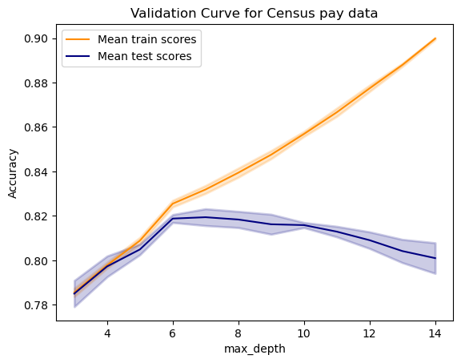
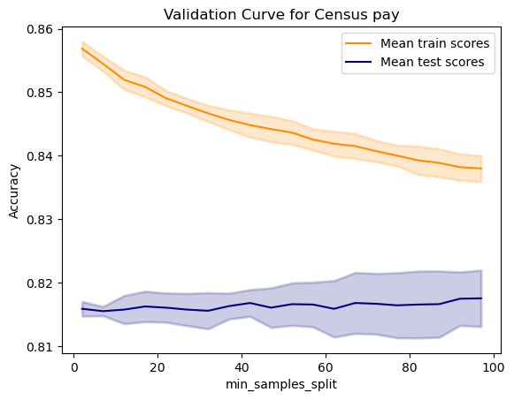
Accuracy/times as follows:

Decision Trees (Prepruned)
Dataset: DS-1
Training Acc | 0.81722
Testing Acc | 0.8088
Train time | 0.0548
Test time | 0.0037

Dataset2:
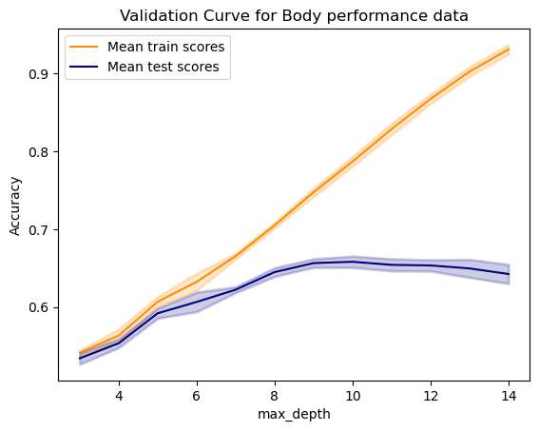
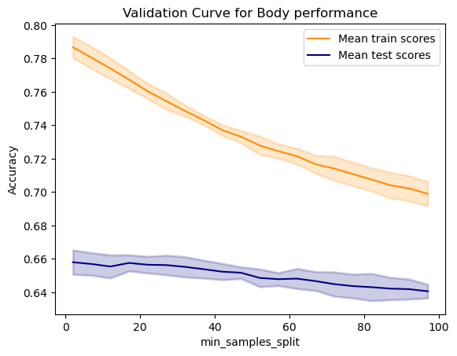
Using similar process, the selected max_depth and min_samples_split were selected from the plots below. The new classifier reduced total nodes from 3941 to 421 and has the following properties:
Max depth =10; min_samples_split=2

Dataset: DS-2
Training Acc | 0.72775
Testing Acc | 0.67695
Train time | 0.0611
Test time  Prepruning analysis:  Maximum depth required for optimal performance for ds1 is more than ds2. This implies the difficult nature of separation for ds2 as it needs a more compelx model to achieve the best accuarcy. | 0.0019

Prepruning analysis:
We can see from the max_depth charts that for bigger values of max_depth, we start to see over fitting. The validation and training accuracies start to diverge at max_depth=6 for DS1 and max_depth=8 for DS2. Why does it happen? Because as we keep increasing depth, the tree starts to capture unimportant patterns in the data by using features that are not related at all or making splits that are too specific to the training data. For DS1, we can see the tree using more of fnlwgt feature which is not that important or relevant.
We see a similar behaviour for min_samples_split with max_depth fixed. However, the direction is opposite. The smaller the value of min_samples_split, more the difference in the accuracies. The min_samples_split defines how many samples should be in a node for it to further split into further nodes. For both sets, there is no advantage to having a bigger minimum number of samples per node before splitting. A smaller min_split_value may also indicate overfitting where as a bigger one shows over-generalization. This trend is also confirmed when we look at the learning curves for DS-1, where the variance is more when min_samples_split =2. This difference would be more pronounced if we do not bind the classifier with max_depth. The testing accuracy is somewhat similar for both datasets.
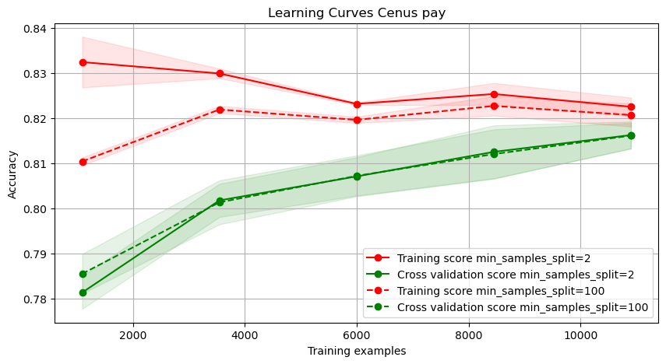Illustration 1: Learning curves: showing effect of min_samples_split for DS-2
Maximum depth required for optimal performance for DS1 is more than DS2. This implies the difficult nature of separation for DS2 as it needs a more compelx model to achieve the best accuarcy.

Cost complexity pruning
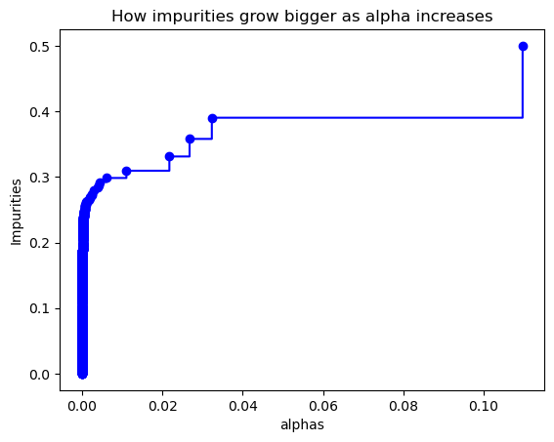

Post pruning works by cutting away the branches it deems are the weekest (do not contribute to a better accuracy). For this type of pruning, I am using training and validation test. As alpha increases, the number of leaves decrease, which means more mixed samples in each leaf which results in a higher impurity (chart for DS1 shown to the left).
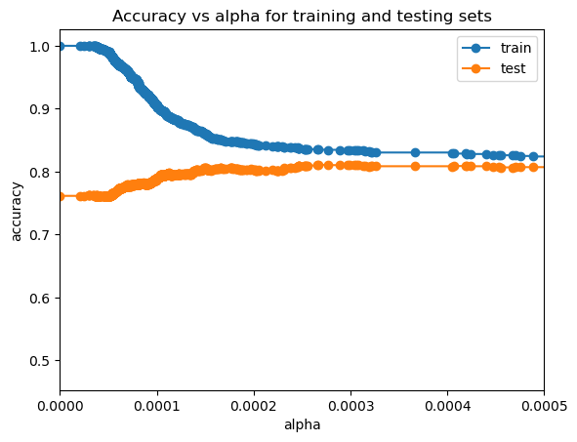Illustration 2: alpha vs accuracy for DS1

Dataset 1 & Dataset 2:
From Illustration 2 on the right for DS1, best accuracy is achieved at alpha= 0.00025. At this value of alpha, the resulting tree has following properties:
Max depth=13, Nodes = 165 =, ccp_alpha=0.00025, criterion='gini', min_samples_leaf=1, min_samples_split=2

‘gini’ index, like entropy, calculates the purity of a node, giving value 0 for when all samples in a node belong to a single group and 0.5, when its all over the place.

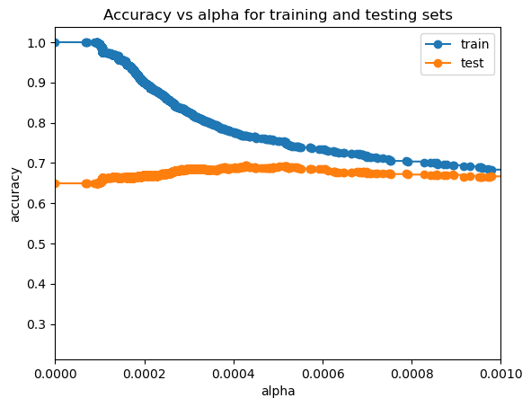Illustration 3: alpha vs accuracy for DS2

After looking at Illustration 3, the best alpha = 0.0005 and resulting classifier has following properties:
Max depth 13, Number of nodes = 497, criterion = ‘gini’

Analysis on postpruning:
Post pruning results in the same depth for the trees for both datasets but number of nodes are very different. Because of difficulty of classification for dataset 2, we have more than twice the number of nodes for this classifier as compared to DS1. Looking at the starting values with alpha = 0 we see that the trees resulting from those values are over fitting the data. As alpha increases, the accuarcies converge for both datasets, resulting in the best alpha value. Lower alpha cause overfitting because it lets the trees go as big as possible by not penalizing bigger trees.
One other thing I noticed after looking at the decision trees (pruned and unpruned) were that some features were very rarely used in the pruned trees. For example, for DS1, feature ‘fnlwgt’ (final weight) was used only once in the pruned trees where as it was used atleast 7 times in umpruned ones. This, I believe, is an indication of what a good feature is in terms of generalization and which is not. Some features like relationship, hours-per-week and education-num were used as top features for splitting for all trees, which indicate their importance for classification.
Prepruning and post pruning produced almost identical results in terms of accuracy.

Final Learning curves(Postpruned):
Dataset 1:
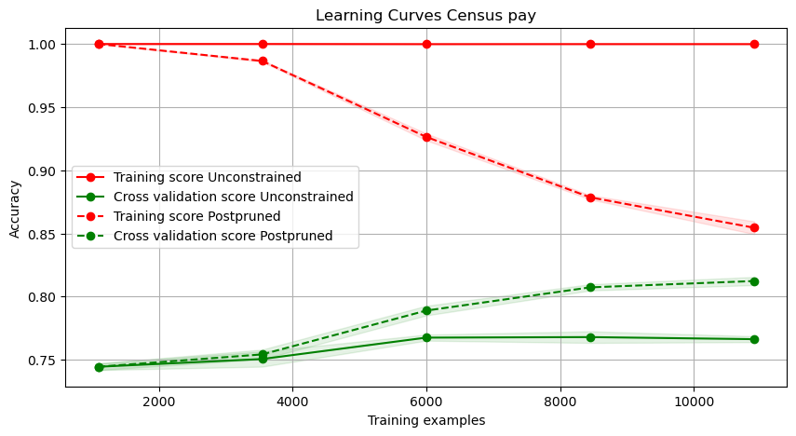

The learning curves shown are that of an unconstrained tree and a post pruned tree. For the case of unconstrained one, we can see the high variance as its overfitting the data with high training accuracy but a very low validation accuracy. It also shows no improvement in generalization after 6000 samples.
The postpruned tree’s learning curve shows good learning progress as it receives more data, however the chart does show that the tree can benefit from more data. This data can be in terms of more samples or some extra features. The slopes show that learning is still ongoing and have not plateaued.

Dataset 2:
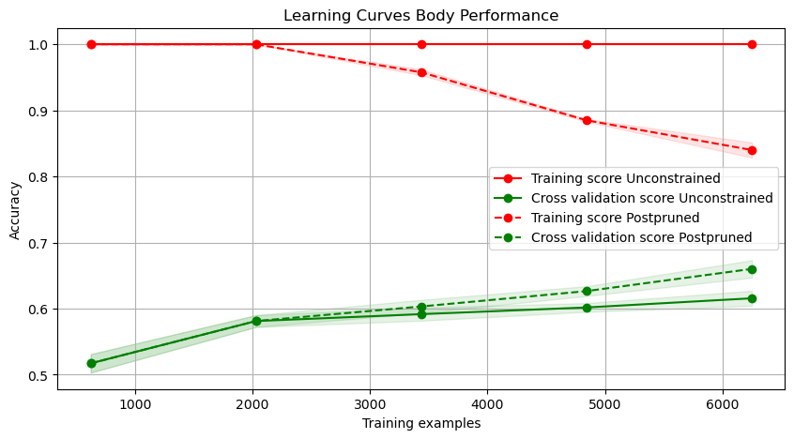

Post pruned trees for DS-2 also performs better in terms of bias and variance as compared to unconstrained trees. After 2000 samples, post pruned trees result in better validation accuracy than unconstrained ones and the training and testing accuracies are moving closer. However this chart also shows that the decision tree can benefit from more data as the curves have not yet reached a plateau. This data can be in terms of more samples or features. In the learning curves, we can see the high variance for both the curves, with it getting better for the pruned trees with more samples. There is insignificant effect on the unconstrained trees.

k Nearest Neighbors:
The approach to the problem was similar to decision trees. I first started by modeling without any constraints and then looked into improving that. My hope was that knn will perform better on DS2 as compared to DS 1 because DS1 had a lot of categorical values and DS2 was primarily a numerical column data. Data is used after standardizing and label encoding the categorical data.

The two metrics I wanted to test were n_neighbors and the type of distance metric using validation curves. The best attributes of the classifiers were:
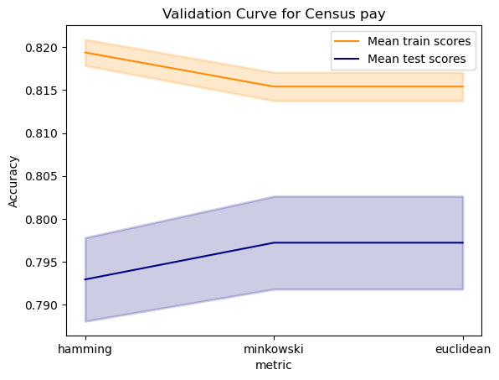
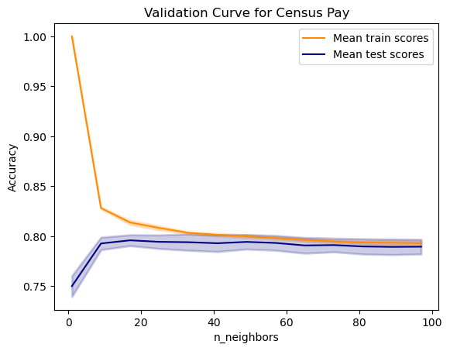
Dataset 1:
- metric='minkowski’
- n_neighbors=15
- weights='uniform'
Testing accuracy=78.98%.
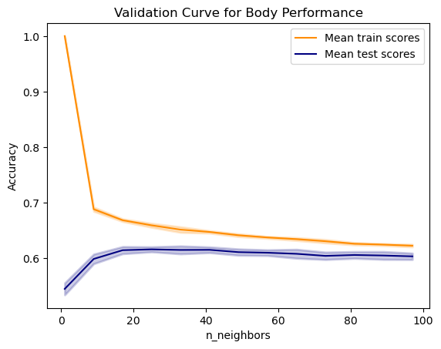
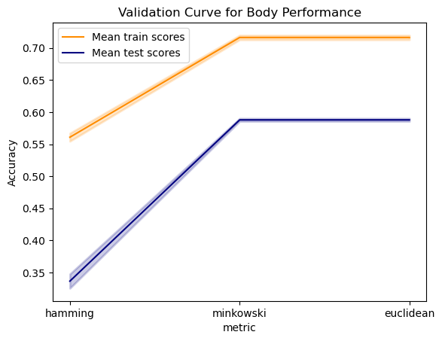
Dataset 2:
-metric='minkowski'
- n_neighbors=25
- weights='distance'
Testing accuracy=63.31%
Analysis of value of k:
Looking at the left charts for n_neighbors vs accuracy, we can see that k=1 leads to overfitting for both datasets where training accuracy is high but testing accuracy is low. A higher k leads to a more smoother decision boundary and reduces overfitting. However, if k gets super high, it may lead to an oversimple model, unable to capture intricacies of the data and underfit. The values for k for the datasets seem a good compromise.
Analysis DT vs KNN:
My expectation that knn will perform better on datatset 2 than dataset 1 was debunked. Both the datasets performed worse than decision trees. So I looked at the biases prevalent in knn and upon investigation found the reasons to include Curse of dimensionality, all features were weighted equally and the most important, its not clear to knn how to define distance metric for catagorical variables and it will assign a difference of 1 between each of the categories.
So I started messing around by giving more weights to certain features before passing the data through KNN. My findings were as follows:
dataset 1:
To battle curse of dimensionality, I chose 8 out of 14 columns that I believe were most important (domain knowledge!). These columns were 'age', 'sex', 'occupation', 'education-num', 'relationship', 'capital-gain', 'capital-loss', 'hours-per-week. Then using, some empirical testing, start fiddling with the weights of each feature and found that upscaling or downscaling a feature (‘age’ from 1 to 0.7 and relationship to 4 times the weight) increased my accuracy from improved from 78.6% to 81.951.
dataset 2:
Similar as dataset 1, I first selected 8/11 columns that I deemed relevant. Then I tweaked the weights of the features before applying knn on it. The weight change per feature was 'sit and bend forward_cm' -> 3*original, 'sit-ups counts' -> 2.7 *original, 'broad jump_cm' -> 0.4*original, body fat_%' -> 0.3*original, ‘age’ ->2.3*original
Testing score increased from 63.3% to 71.38%
Learning Curves
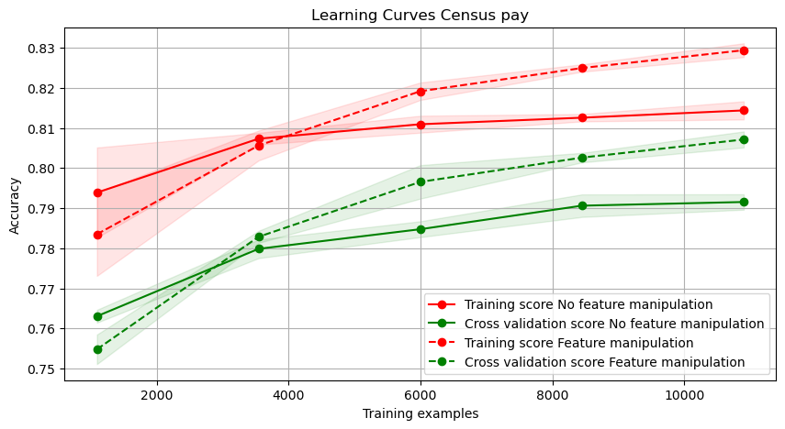
Without any feature manipulation, we can see that both training and testing accuracies are below the ones in which we have manipulated the features.
There is a high variance as shown by the difference between the curves for both models. The bias for the models also appear similar as none seem to be overfitting.
This chart also shows that the model that is dealing with manipulated features continues to learn while the other model has sort of plateaued and no more data will help it.

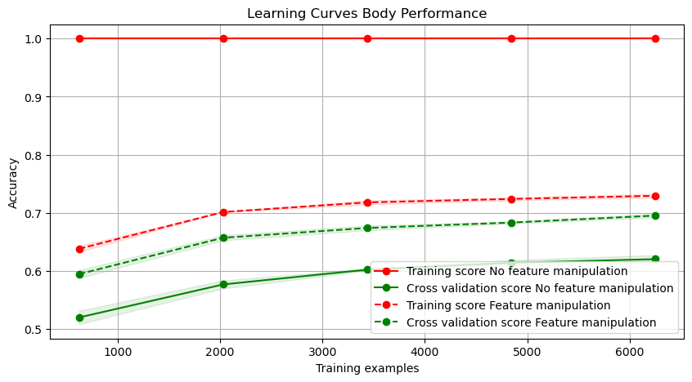
Because of the weights as ‘distance’ the training accuracy is a 100 as the training samples are on top of each other, making the closest sample to the traing data itself. Inverse of distance becomes infinity and thus training data gets all right answers.
There is a high bias and variance in the no-feature-manipulation model and there seems to be no bias and variance for the model dealing with feature manipulation. The validation accuracy after feature manipulation is better than before and the accuracy improves as data increases. However, with feature manipulation, as the data increases, both training and testing accuracies improve and the distance between the two seem to be closing in.

Neural networks:
My first thought was to figure out a way to test emperically how many layers we need, followed by the number of neurons in each layer. For most tasks, we do not need more than 2-3 layers. I tested from 4 to 1 layers with varying no. of neurons/layer.
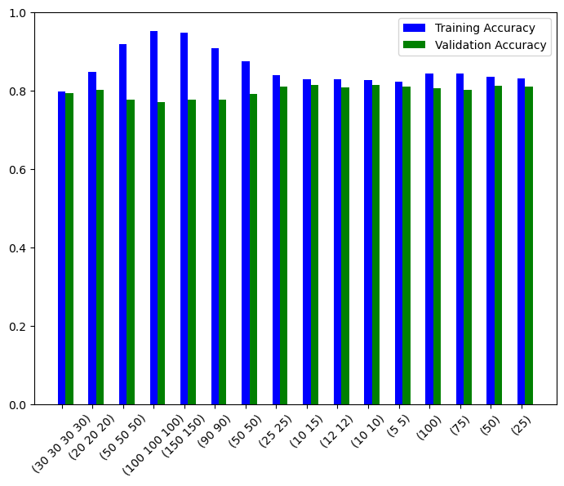
Dataset1:
From the chart on the right side, I chose the one with maximum validation results.
The numbers found were further looked at a finer granuality to get the final values. The properties of the classifier are:
- solver='adam',
- learning_rate_init=0.001,
- activation='relu',
- hidden_layer_sizes =(10, 15)

As the layers neurons pre layer increased, training accuracy increased as well but not always the valudation accuracy.

Loss curve:

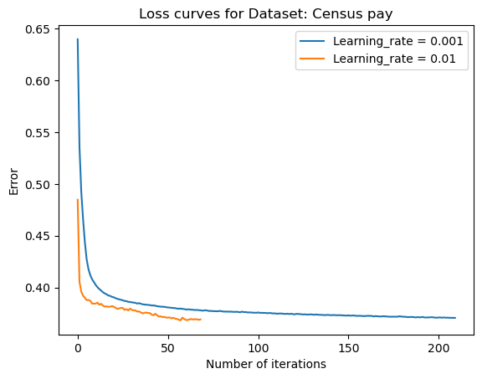
I am using a learning_rate of 0.001 which produces the best accuracy. A larger learning rate was converging faster, getting the same lowest error but it is less smooth and did not achieve the highest accuracy.
It should be noted though that for this dataset, it did not make a huge difference in the accuracies for learning rate=0.001 or 0.01.
The learning_rate shown below expresses the similarity for using the slightly different learning rates.
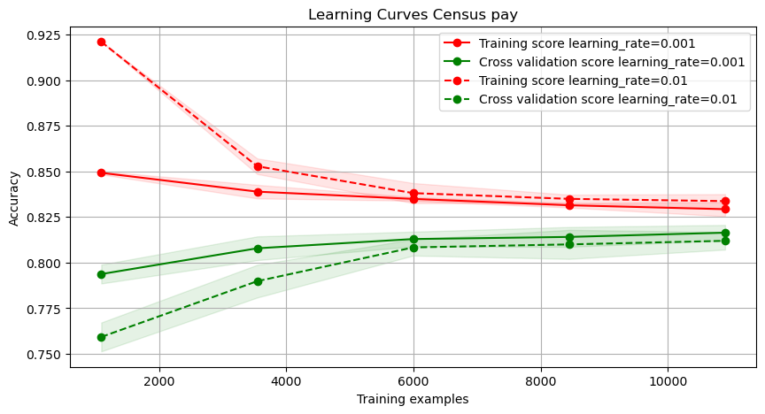
The learning curves on the left also show the difference in using a bigger and a smaller learning rate. The model using a bigger learning rate converges faster towards almost the same accuracy but in this case, provides a slightly less validation accruacy.

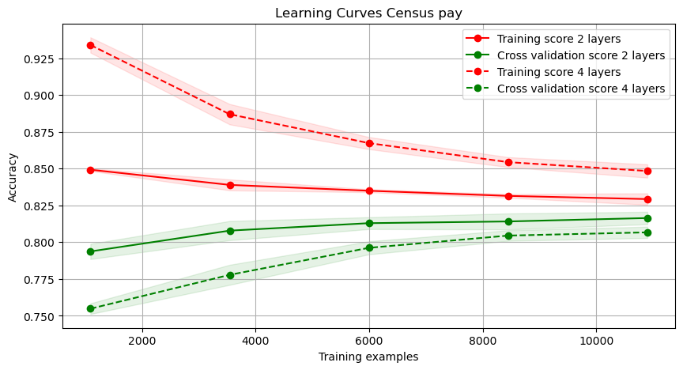
Learning curves
The chart on the right shows learning curves for the 2-layers network which is my final model. It also shows curves for the 4 layer network for comparison purposes. The final model shows low bias and low variance. As compared to these final curves, the dotted lines (4 layers) have a relatively high variance and even though the training data performs better with more layers, validation accuracy decreases, showing less than optimal generalization. This trend was seen through out that increasing layers or neurons per layer always resulted in better training accuracy but lower validation accuracy. This model aso shows that the learning as plateaued and no more data will be helpful in learning a better model with these parameters atlesast. Another interesting thing about the learning curve is that for 2 layers, the learning is indeed very slow both for validation and training set.

Dataset 2 : Body Performance
Just like dataset1, the values for parameters ‘hidden layers’, ‘learning_rate_init’ were found using emperical analysis of the validation curves. The right chart shows the loss curve (blue line) for the final model.
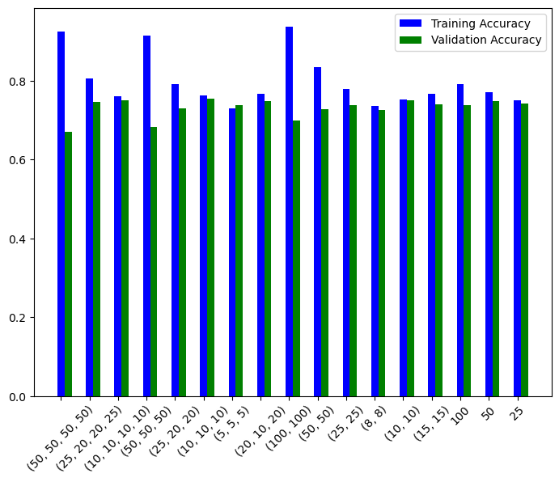
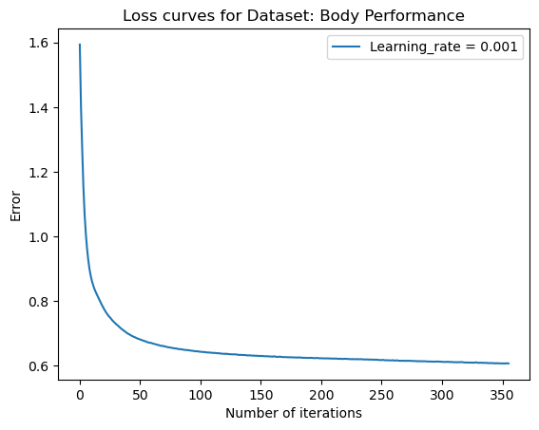

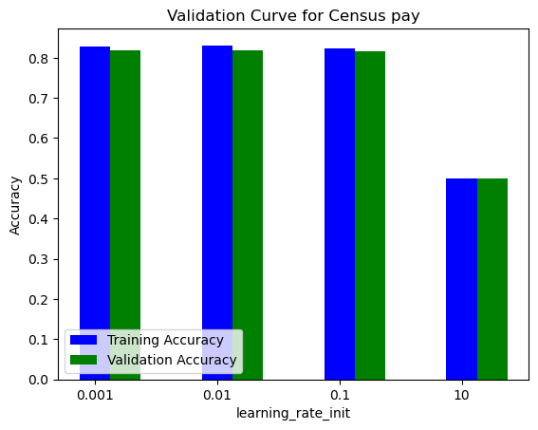

We can see from the chart above on the left that for hidden layers with high number of neurons or for many layers, the training accuracy is very high compared to validation accuracy. Final model selected is the follows:
solver='adam', learning_rate_init=0.001, activation='relu', hidden_layer_sizes =(10, 10))

The chart on the right above shows the loss curve for final model (learning rate=0.001). This loss is the cross entropy loss calculated over the data.

Learning curve:
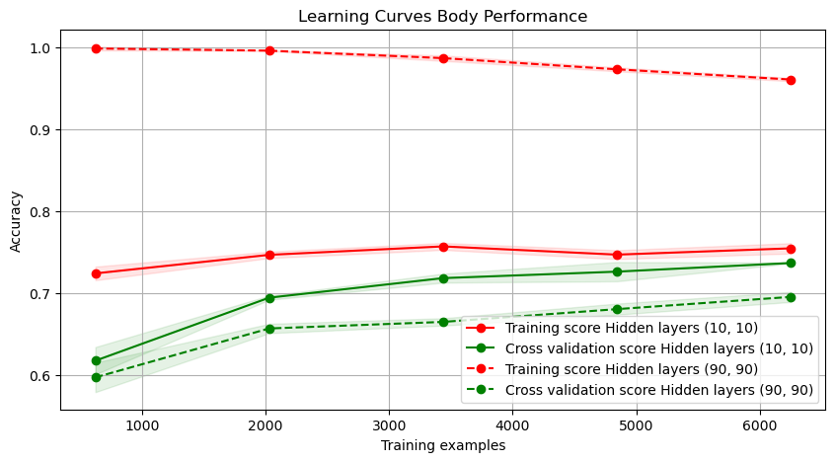

The solid lines below represent the final learning curves for dataset 2. The curves shows no bias and very little variance. Dotted lines, showing the curves for a 2 layer but many neurons network, show a very high variance in the model.

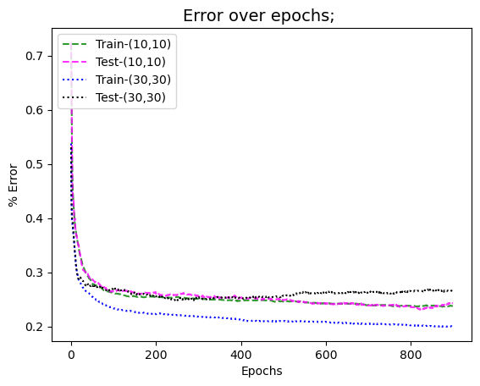

Analysis:
When I calculated loss for my network (model with (10,10) hidden layers), no matter how many iterations I ran, I did not see any overfitting. There was no room for it. However, when I increased number of neurons in each layer from 10,10 to 30,30 and ran the analysis again, I could see the model overfitting after iterations. This is shown in the chart on the right, where green and pink dashed lines stay on top of each other whereas the curves for model 2 (30,30) start diverging after about 25 iterations.
This proves that number of iterations in a neural network can cause overfitting if there are more than enough neurons and/or layers

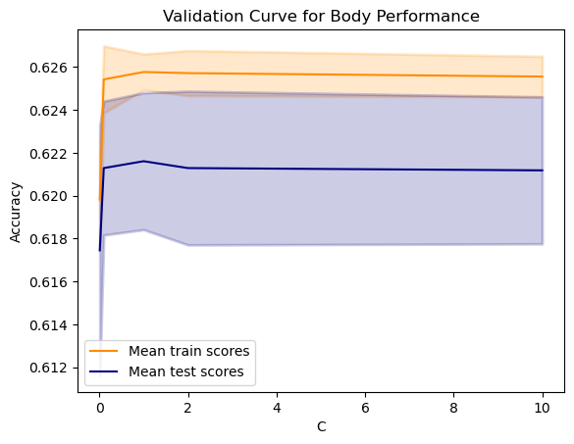
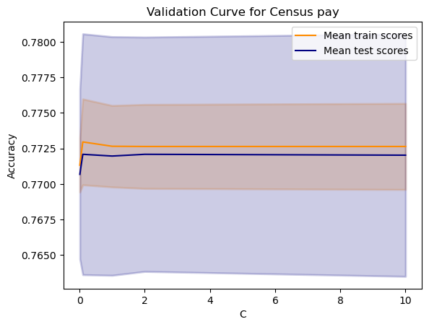
SVM (Linear)
Dataset 1 & Dataset 2:
I started with the linear kernel of the SVM which is really good for solving lienarly separable data without overfitting (or maximizing margin). I used validation curves to see if C mattered a lot for linear classifier. As shown in the charts to the right, it does not make much of a difference what penalty we put on misclassifying data.

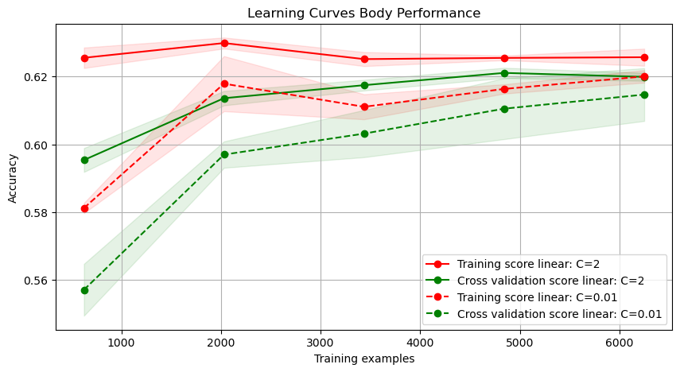
Learning curve for with different Cs
Because the data is not linearly separable, I expected to see underfitting or high bias in the learning curves for the linear kernel. Because the highest accuracy received so far for dataset 2 is 73%, an accuracy of 60% is indeed showing high bias.
Another interesting trend to notice is that smaller C leads to lesser accuarcy because we dont care much about accuracy but more about the margin.

RBF kernel:
Dataset1 & Dataset 2:
Using validation curves, I find the best values for C and gamma, both of which define the shape of the decision boundary. Where a smaller C means more margin between classes, a smaller gamma means simpler as contrast to complex boundaries. The effect of C was not noticeable as much in the liner kernel case because its not easy to overfit when considering linear decision boundaries. However, in the rbf case, we can see that overfitting occurs around C >2 . We can also see area of overfitting with gamma > 0.06.
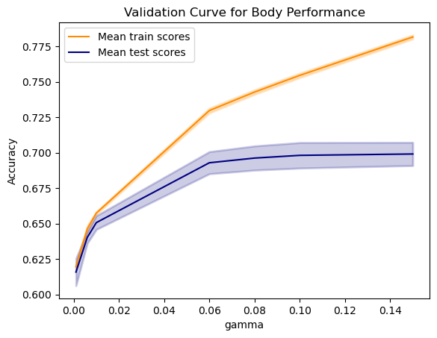
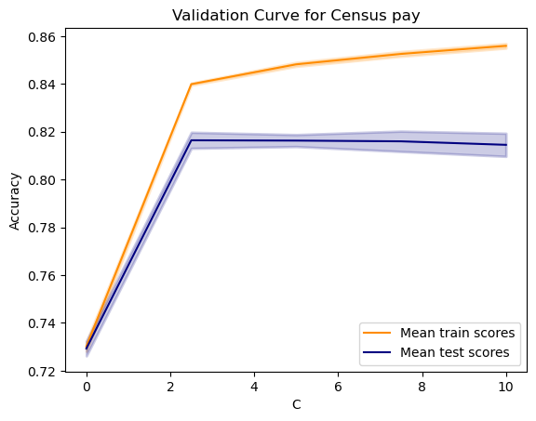
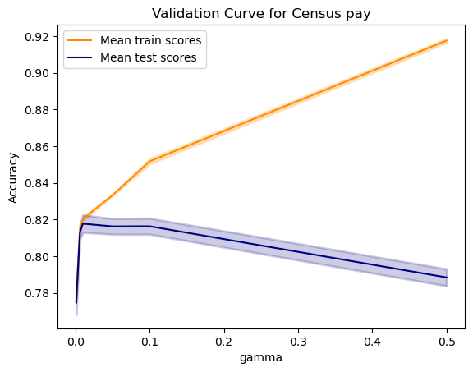
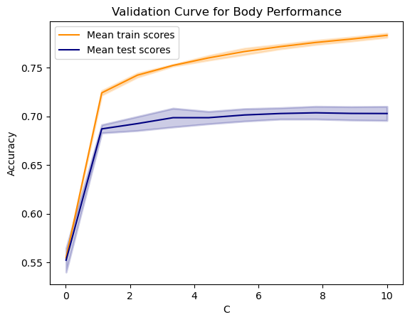

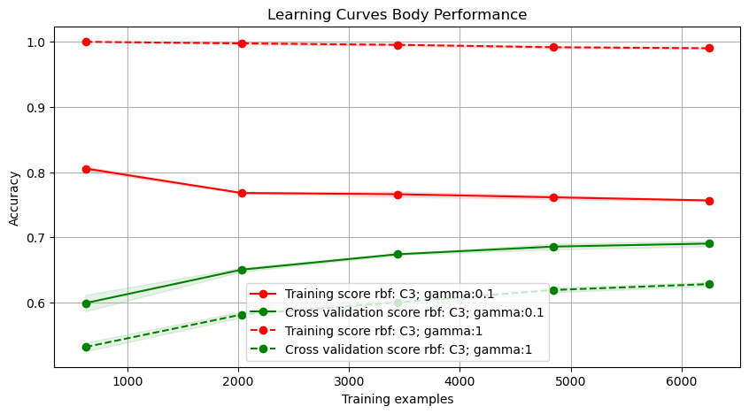

Relationship between higher values of gamma and overfitting can be seen in the learning curves on the right. Dotted lines with a higher gamma value have a very high variance. It is performing excellent on the training data but performing poorly on the test data. On the contrary, a smaller gamma is able to generalize better.

Learning Curves for Linear and RBF kernel:
The left chart below shows the learning curves for linear and rbf kernels for dataset 1 and chart on the right shows learning curves for linear/rbf kernels for dataset 2. rbf kernels show higher training and testing accuracy on both the datasets even though they exhibit slight variance. The solid lines for linear kernel shows high bias becuase of the linear kernel underfitting the data.
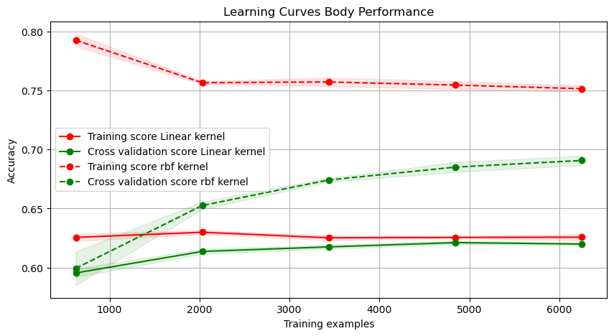
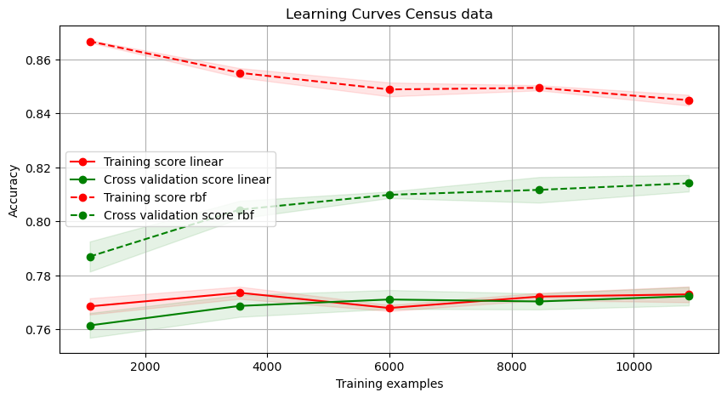

Adaboost:
For adaboost, I started by using the classifier’s default settings and testing on the datasets. The default classifier has learning rate of 1, 50 estimators and decision tree stumps as base estimator. The classifier performed similarly on scaled and unscaled data.

DS1: Training Acc 82.61%, Testing Acc. 82.33%; DS2: Training Acc 60.84%, Testing Acc. 60.129%

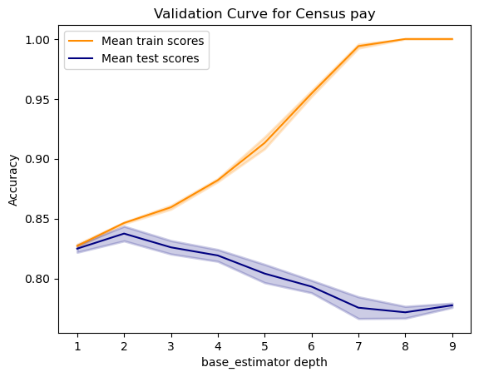
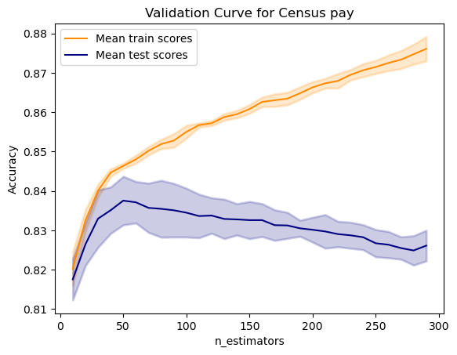
Tuning:
For tuning, I am looking into max_depth of the base estimator and number of estimators in the ensemble.
Dataset 1:
For dataset1, I had a good accuracy to begin with. I looked into the validation charts for these parameters to look for a more favorable combination. My final classifier had following characteristics:
base_estimator_depth =2, n_estimators=50.
We can see from the charts on the right that as the base_estimaror depth increases, the model tends to start overfitting
After tweaking, testing accuracy improved by 1% and training time improved 10 times.

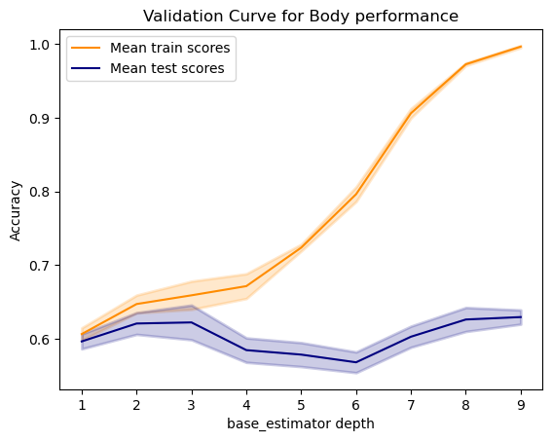
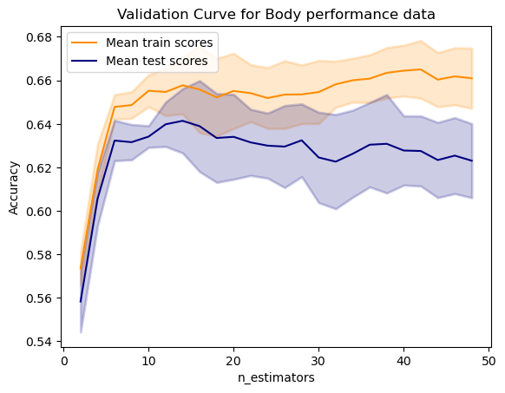
Dataset 2:
Similar process was used as dataset 1 to find optimal params for the classifier. However, interestingly, n_estimators were very few compared to DS1. I believe it is because the dataset 2 does not have many outliers that need to be tweaked by subsequent classifiers. The optimal depth of the trees was 1 more than for DS1. I believe it to be the more complicated nature of dataset 2. Final classifier had the properties: base_estimator_depth =3, n_estimators=12.
After tweaking params, testing accuracy increased by 6.3%!

Analysis: One interesting thing I noticed was how estimator weights are all set to 1. This is an outcome of using SAMME.R algorithm instead of SAMME algorithm. They are both calculated differently and while the final answer in SAMME does include the estimtor weight in its calculation, SAMME.R just includes the weighted probablity estimate by the estimators. So it essentially means that the results from all estimators are equally weighted. The SAMME.R was used because of better reseults as well as faster runtime. Learning_rate also doesn’t affect when its

Learning Curves:
For dataset 1 and dataset 2, tuning improved the variance as well as the accuracy of the model.
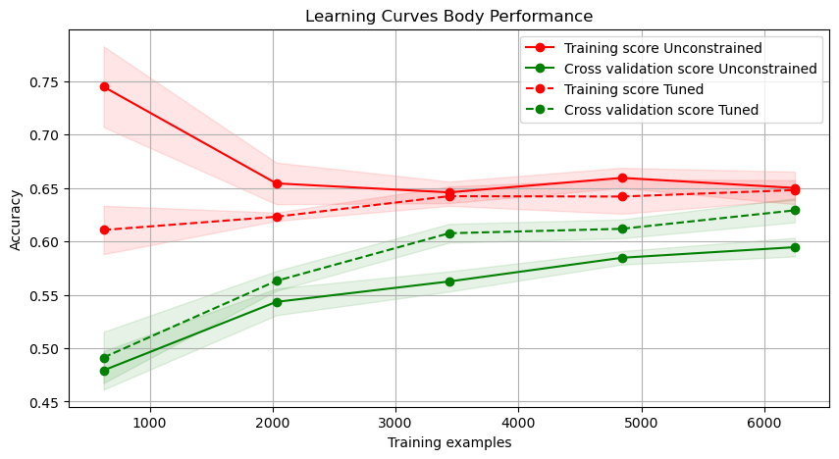
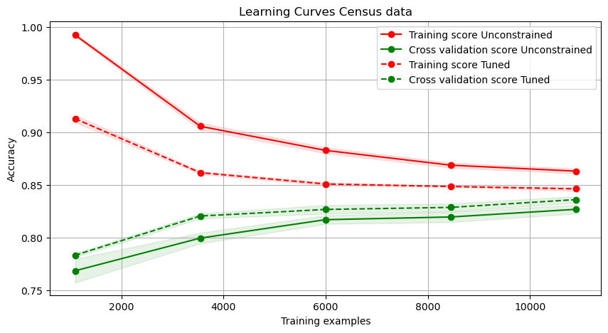

Timing Analysis:
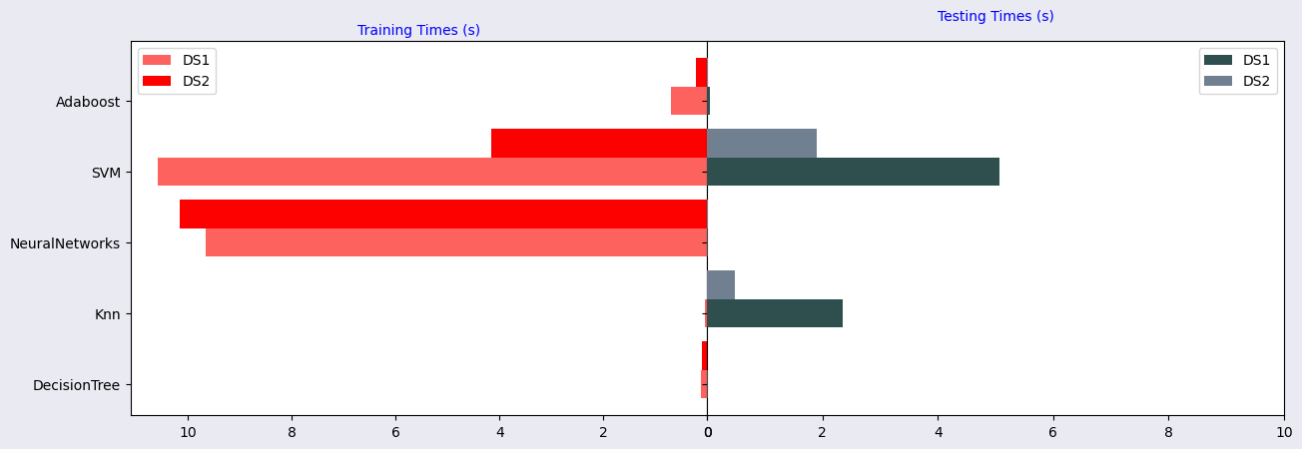
From looking at the wall clock times for training and testing, some observations are as follows:
Decision Trees take more time training than testing. This is because they are eager learners, trying to learn everything from the data before seeing the test data. This makes the training time longer, but testing time slower, as test data just has to traverse one branch of the tree and will have to read as many as log(depth) nodes.
KNN is a lazy learner because they do nothing but stuff them in some storage and will consult the data when needed. So their training time is pretty low but that is offset by a high testing time. This is the only learner with a higher testing than training time
Neural networks also fall in the eager learner category as they try to learn the weights before encountering the test data. They learn all they need to learn from the training data. They took longest training among all the machine learning algorithms but also produced the most accuracy with least effort.
SVM is a bunch of machine learning algorithms that can use different kernels to see different relationships between data. These kernels affect the training and testing times for the datasets. They are lazy and eager at the same time in a way that they want to learn from the data but only consider a few of the training points to decide on the decision boundary (support vectors). It is also one of the slowest algorithms as it took a long time to train and test the data.
Adaboost has a longer training time compared to testing time. Reason is that it trains several weak learners (decision trees in my case) one after the other, calculating and adjusting weights on the data in each iteration. For testing, it just has to get an answer from each of the trees and vote in case of classification.

Comparison of all Models:
